Translators
English Template -Roula
Sepedi - Mari
Sesotho - Mbuyiselwa Moloi 2012164071@ufs4life.ac.za
Setswana -
siSwati -
Tshivenda – Mari, Fulufhelo
Xitsonga - Mari
Afrikaans – Tjaart, Benita
isiNdebele -
isiXhosa - Fanelwa
isiZulu – Nomusa
Shona -Amos, Rose
Ndebele -
French -
Swahili -Edythe
Lingala -
Portuguese - Elsa Oliveira elsa.alexandra.oliveira@gmail.com
Somali -

ENGLISH Text
Stay safe and keep others safe during CoronaVirus times

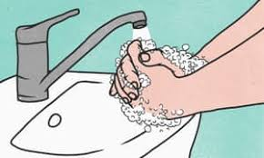 | PERSONAL CARE  Wash your hands often with soap for 20 seconds or use hand sanitizer (60% alcohol).  Avoid touching your face and surfaces with unwashed hands.  Cover your mouth with your elbow or a tissue when you sneeze or cough. Dispose the tissue off properly after use.
SOCIAL DISTANCING
Avoid using public transport where possible
Avoid close contact with people especially those with cold or flu-like symptoms
Do not kiss, hug or touch one another.
Public gatherings of more than 100 people are not allowed; avoid crowded places in any case.

FEELING SICK
Symptoms and What to do if feeling unwell
COVID-19 can cause fever, sore throat, cough and body aches.
If your symptoms get worse or you have difficulty breathing, then urgently contact your clinic or doctor.

Contact the General Public Hotline 0800 029 999 for any questions or when you feel unwell. It operates from Monday to Friday 08:00-16:00. Alternatively use the WhatsApp line at 0600 123 456

Disclaimer: The list is not exhaustive as it stands. SAYAS shares here the basics only - for more detailed advice, medical experts can advise further.
